|  |
| --- |
| Circle Language Spec: Commands |

## Command References in an Active Clause in a Diagram

This article demonstrates a situation of command objects.

This article illustrates how command references in an active clause look in a diagram.

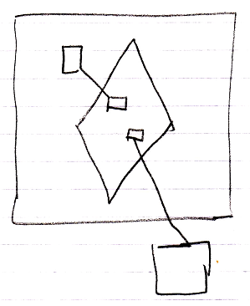

The large square is the command definition, that the active clause is in. The diamond is the active clause. The smaller squares inside the diamond are command references in an active clause. They are actually *public* command references. This makes the command references parameters of the active clause. The command references have object lines, solid ones, going outside, ending at the targets of the command references.